**Table #**

*Pooled Results for Logistic Regression Model Predicting Consumer Behaviors*

| Term | *OR* | *b* | *SE* (*b*) | *t* | *df* | *p* |
| --- | --- | --- | --- | --- | --- | --- |
| Intercept | 0.86 | -0.15 | 0.07 | -2.09 | 811.85 | 0.037 |
| FramingCode1 | 1.13 | 0.12 | 0.17 | 0.71 | 882.44 | 0.479 |
| FramingCode2 | 1.66 | 0.50 | 0.15 | 3.32 | 937.44 | 0.001 |
| NormCode1 | 1.15 | 0.14 | 0.11 | 1.22 | 894.46 | 0.224 |
| NormCode2 | 1.00 | 0.00 | 0.06 | 0.03 | 984.07 | 0.974 |
| NormCode3 | 1.01 | 0.01 | 0.05 | 0.29 | 1,025.11 | 0.771 |
| NormCode4 | 1.02 | 0.02 | 0.04 | 0.48 | 955.66 | 0.628 |
| Biospheric Values | 1.66 | 0.51 | 0.11 | 4.80 | 1,004.89 | < .001 |
| Altruistic Values | 1.25 | 0.23 | 0.15 | 1.53 | 946.39 | 0.127 |
| Egoistic Values | 0.48 | -0.73 | 0.10 | -7.29 | 751.72 | < .001 |
| Hedonic Values | 1.01 | 0.01 | 0.12 | 0.07 | 847.89 | 0.948 |
| Ingroup Identification | 1.01 | 0.01 | 0.07 | 0.14 | 856.02 | 0.888 |
| Self-deceptive Enhancement | 0.79 | -0.24 | 0.09 | -2.62 | 1,033.26 | 0.009 |
| Impression Management | 0.80 | -0.23 | 0.09 | -2.56 | 984.40 | 0.011 |
| Clothing Interest | 1.05 | 0.05 | 0.10 | 0.54 | 1,002.21 | 0.590 |
| Gender | 0.99 | -0.01 | 0.17 | -0.08 | 219.03 | 0.936 |
| Age | 0.92 | -0.09 | 0.05 | -1.73 | 57.42 | 0.088 |
| FramingCode1 x NormCode1 | 1.59 | 0.46 | 0.27 | 1.73 | 1,018.11 | 0.084 |
| FramingCode2 x NormCode1 | 1.42 | 0.35 | 0.24 | 1.43 | 1,000.36 | 0.154 |
| FramingCode1 x NormCode2 | 0.94 | -0.06 | 0.16 | -0.36 | 829.44 | 0.723 |
| FramingCode2 x NormCode2 | 0.99 | -0.01 | 0.13 | -0.07 | 1,020.08 | 0.943 |
| FramingCode1 x NormCode3 | 1.07 | 0.06 | 0.11 | 0.58 | 936.83 | 0.559 |
| FramingCode2 x NormCode3 | 1.09 | 0.09 | 0.10 | 0.87 | 1,027.20 | 0.385 |
| FramingCode1 x NormCode4 | 1.03 | 0.03 | 0.09 | 0.30 | 532.64 | 0.765 |
| FramingCode2 x NormCode4 | 0.96 | -0.04 | 0.07 | -0.55 | 838.86 | 0.580 |
| FramingCode1 x Biospheric Values | 0.83 | -0.19 | 0.27 | -0.69 | 1,010.64 | 0.488 |
| FramingCode2 x Biospheric Values | 1.48 | 0.39 | 0.21 | 1.83 | 966.99 | 0.068 |
| NormCode1 x Biospheric Values | 1.31 | 0.27 | 0.16 | 1.68 | 953.88 | 0.093 |
| NormCode2 x Biospheric Values | 1.06 | 0.06 | 0.09 | 0.66 | 941.57 | 0.509 |
| NormCode3 x Biospheric Values | 1.01 | 0.01 | 0.07 | 0.12 | 929.20 | 0.901 |
| NormCode4 x Biospheric Values | 1.01 | 0.01 | 0.06 | 0.21 | 718.24 | 0.837 |
| FramingCode1 x Altruistic Values | 2.02 | 0.70 | 0.35 | 1.98 | 1,018.33 | 0.047 |
| FramingCode2 x Altruistic Values | 0.46 | -0.77 | 0.30 | -2.53 | 962.73 | 0.012 |
| NormCode1 x Altruistic Values | 0.58 | -0.54 | 0.24 | -2.24 | 985.71 | 0.025 |
| NormCode2 x Altruistic Values | 1.23 | 0.20 | 0.13 | 1.58 | 1,034.11 | 0.115 |
| NormCode3 x Altruistic Values | 1.08 | 0.08 | 0.09 | 0.83 | 1,003.03 | 0.407 |
| NormCode4 x Altruistic Values | 1.07 | 0.07 | 0.07 | 0.95 | 491.64 | 0.343 |
| FramingCode1 x Egoistic Values | 0.61 | -0.49 | 0.24 | -2.09 | 892.82 | 0.037 |
| FramingCode2 x Egoistic Values | 0.90 | -0.10 | 0.20 | -0.52 | 1,034.64 | 0.605 |
| NormCode1 x Egoistic Values | 1.02 | 0.02 | 0.16 | 0.14 | 955.96 | 0.891 |
| NormCode2 x Egoistic Values | 0.95 | -0.05 | 0.09 | -0.57 | 1,022.18 | 0.567 |
| NormCode3 x Egoistic Values | 1.06 | 0.06 | 0.06 | 0.97 | 910.69 | 0.332 |
| NormCode4 x Egoistic Values | 0.96 | -0.04 | 0.05 | -0.77 | 779.88 | 0.443 |
| FramingCode1 x Hedonic Values | 0.79 | -0.24 | 0.29 | -0.81 | 939.09 | 0.420 |
| FramingCode2 x Hedonic Values | 1.01 | 0.01 | 0.25 | 0.03 | 913.63 | 0.979 |
| NormCode1 x Hedonic Values | 0.97 | -0.03 | 0.20 | -0.14 | 937.34 | 0.887 |
| NormCode2 x Hedonic Values | 0.94 | -0.06 | 0.11 | -0.58 | 1,033.42 | 0.563 |
| NormCode3 x Hedonic Values | 0.91 | -0.09 | 0.08 | -1.16 | 906.44 | 0.247 |
| NormCode4 x Hedonic Values | 0.97 | -0.03 | 0.06 | -0.50 | 960.15 | 0.614 |
| FramingCode1 x Ingroup Identification | 1.02 | 0.02 | 0.17 | 0.13 | 999.83 | 0.896 |
| FramingCode2 x Ingroup Identification | 1.07 | 0.07 | 0.15 | 0.46 | 1,015.90 | 0.647 |
| NormCode1 x Ingroup Identification | 0.96 | -0.04 | 0.11 | -0.39 | 1,013.44 | 0.699 |
| NormCode2 x Ingroup Identification | 0.97 | -0.03 | 0.07 | -0.40 | 1,000.68 | 0.688 |
| NormCode3 x Ingroup Identification | 1.01 | 0.01 | 0.05 | 0.27 | 965.35 | 0.791 |
| NormCode4 x Ingroup Identification | 0.97 | -0.03 | 0.04 | -0.74 | 532.82 | 0.461 |
| FramingCode1 x NormCode1 x Biospheric Values | 0.72 | -0.33 | 0.40 | -0.83 | 937.25 | 0.409 |
| FramingCode2 x NormCode1 x Biospheric Values | 0.91 | -0.10 | 0.35 | -0.28 | 982.19 | 0.782 |
| FramingCode1 x NormCode2 x Biospheric Values | 1.16 | 0.15 | 0.24 | 0.63 | 952.58 | 0.526 |
| FramingCode2 x NormCode2 x Biospheric Values | 0.95 | -0.05 | 0.19 | -0.28 | 968.58 | 0.782 |
| FramingCode1 x NormCode3 x Biospheric Values | 1.12 | 0.11 | 0.17 | 0.66 | 922.00 | 0.508 |
| FramingCode2 x NormCode3 x Biospheric Values | 0.98 | -0.02 | 0.13 | -0.17 | 1,022.77 | 0.867 |
| FramingCode1 x NormCode4 x Biospheric Values | 1.39 | 0.33 | 0.16 | 2.12 | 721.93 | 0.035 |
| FramingCode2 x NormCode4 x Biospheric Values | 0.95 | -0.05 | 0.11 | -0.45 | 674.06 | 0.654 |
| FramingCode1 x NormCode1 x Altruistic Values | 1.09 | 0.08 | 0.57 | 0.15 | 987.33 | 0.885 |
| FramingCode2 x NormCode1 x Altruistic Values | 1.43 | 0.36 | 0.54 | 0.67 | 987.42 | 0.502 |
| FramingCode1 x NormCode2 x Altruistic Values | 0.90 | -0.10 | 0.31 | -0.32 | 1,024.70 | 0.749 |
| FramingCode2 x NormCode2 x Altruistic Values | 1.59 | 0.47 | 0.27 | 1.70 | 1,028.55 | 0.090 |
| FramingCode1 x NormCode3 x Altruistic Values | 0.90 | -0.11 | 0.24 | -0.44 | 974.54 | 0.657 |
| FramingCode2 x NormCode3 x Altruistic Values | 1.32 | 0.28 | 0.19 | 1.44 | 1,024.86 | 0.150 |
| FramingCode1 x NormCode4 x Altruistic Values | 0.70 | -0.35 | 0.17 | -2.02 | 909.38 | 0.043 |
| FramingCode2 x NormCode4 x Altruistic Values | 1.09 | 0.08 | 0.14 | 0.61 | 682.51 | 0.540 |
| FramingCode1 x NormCode1 x Egoistic Values | 1.00 | 0.00 | 0.40 | 0.00 | 957.78 | 0.996 |
| FramingCode2 x NormCode1 x Egoistic Values | 0.86 | -0.15 | 0.33 | -0.46 | 832.98 | 0.644 |
| FramingCode1 x NormCode2 x Egoistic Values | 1.49 | 0.40 | 0.21 | 1.92 | 1,018.34 | 0.055 |
| FramingCode2 x NormCode2 x Egoistic Values | 1.04 | 0.04 | 0.18 | 0.22 | 1,029.61 | 0.830 |
| FramingCode1 x NormCode3 x Egoistic Values | 1.11 | 0.10 | 0.14 | 0.76 | 838.87 | 0.446 |
| FramingCode2 x NormCode3 x Egoistic Values | 0.94 | -0.06 | 0.13 | -0.50 | 969.87 | 0.617 |
| FramingCode1 x NormCode4 x Egoistic Values | 1.14 | 0.13 | 0.14 | 0.99 | 167.62 | 0.323 |
| FramingCode2 x NormCode4 x Egoistic Values | 1.04 | 0.04 | 0.11 | 0.35 | 542.60 | 0.730 |
| FramingCode1 x NormCode1 x Hedonic Values | 1.37 | 0.31 | 0.48 | 0.65 | 990.28 | 0.514 |
| FramingCode2 x NormCode1 x Hedonic Values | 0.84 | -0.17 | 0.42 | -0.41 | 622.66 | 0.683 |
| FramingCode1 x NormCode2 x Hedonic Values | 0.68 | -0.39 | 0.26 | -1.49 | 984.20 | 0.137 |
| FramingCode2 x NormCode2 x Hedonic Values | 1.15 | 0.14 | 0.23 | 0.61 | 991.02 | 0.540 |
| FramingCode1 x NormCode3 x Hedonic Values | 0.98 | -0.02 | 0.19 | -0.10 | 766.41 | 0.917 |
| FramingCode2 x NormCode3 x Hedonic Values | 1.25 | 0.22 | 0.16 | 1.39 | 935.24 | 0.164 |
| FramingCode1 x NormCode4 x Hedonic Values | 0.96 | -0.04 | 0.14 | -0.30 | 958.51 | 0.760 |
| FramingCode2 x NormCode4 x Hedonic Values | 1.11 | 0.11 | 0.12 | 0.89 | 525.51 | 0.375 |
| FramingCode1 x NormCode1 x Ingroup Identification | 0.96 | -0.05 | 0.26 | -0.17 | 1,009.36 | 0.864 |
| FramingCode2 x NormCode1 x Ingroup Identification | 1.13 | 0.12 | 0.23 | 0.52 | 964.41 | 0.603 |
| FramingCode1 x NormCode2 x Ingroup Identification | 1.28 | 0.25 | 0.17 | 1.43 | 776.75 | 0.153 |
| FramingCode2 x NormCode2 x Ingroup Identification | 1.12 | 0.11 | 0.14 | 0.82 | 985.05 | 0.415 |
| FramingCode1 x NormCode3 x Ingroup Identification | 1.01 | 0.01 | 0.11 | 0.13 | 899.92 | 0.900 |
| FramingCode2 x NormCode3 x Ingroup Identification | 1.04 | 0.04 | 0.10 | 0.44 | 1,022.06 | 0.658 |
| FramingCode1 x NormCode4 x Ingroup Identification | 0.97 | -0.03 | 0.09 | -0.35 | 920.72 | 0.729 |
| FramingCode2 x NormCode4 x Ingroup Identification | 1.04 | 0.04 | 0.08 | 0.48 | 715.94 | 0.632 |

*Note.* Categorical predictors are coded using orthogonal contrast codes. Continuous predictors are mean centered. *b* is a column of the unstandardized regression coefficients. *b\** is a column of the standardized regression coefficients. *OR* is a column of odds ratios.

**Table #**

*Pooled ANOVA Table for Model Predicting Consumer Behaviors*

|  | *F* | *df1* | *df2* | *p* |
| --- | --- | --- | --- | --- |
| Framing Condition | 5.91 | 2 | 11621.44 | .003 |
| Norm Condition | 0.42 | 4 | 1795.26 | .797 |
| Biospheric Values | 23.76 | 1 | 18929.79 | < .001 |
| Altruistic Values | 2.33 | 1 | 15316.29 | .127 |
| Egoistic Values | 59.35 | 1 | 3235.10 | < .001 |
| Hedonic Values | 0.02 | 1 | 345328.62 | .893 |
| Ingroup Identification | 0.01 | 1 | 8926.29 | .938 |
| Self-deceptive Enhancement | 6.93 | 1 | 1151271.30 | .008 |
| Impression Management | 6.59 | 1 | 25780.06 | .010 |
| Clothing Interest | 0.28 | 1 | 44602.45 | .595 |
| Gender | -0.01 | 1 | 981.23 | 1.000 |
| Age | 3.03 | 1 | 77.38 | .086 |
| Framing x Norm | 0.85 | 8 | 11802.27 | .554 |
| Framing x Biospheric Values | 1.95 | 2 | 31941.74 | .142 |
| Norm x Biospheric Values | 0.87 | 4 | 2157.91 | .478 |
| Framing x Altruistic Values | 5.11 | 2 | 289927.89 | .006 |
| Norm x Altruistic Values | 2.35 | 4 | 10056.48 | .052 |
| Framing x Egoistic Values | 2.35 | 2 | 5639.24 | .095 |
| Norm x Egoistic Values | 0.45 | 4 | 1739.09 | .774 |
| Framing x Hedonic Values | 0.32 | 2 | 10144.25 | .729 |
| Norm x Hedonic Values | 0.49 | 4 | 73732.36 | .742 |
| Framing x Ingroup Identification | 0.11 | 2 | 18834.69 | .901 |
| Norm x Ingroup Identification | 0.24 | 4 | 9488.21 | .916 |
| Framing x Norm x Biospheric Values | 0.80 | 8 | 1981.71 | .604 |
| Framing x Norm x Altruistic Values | 1.33 | 8 | 49675.93 | .221 |
| Framing x Norm x Egoistic Values | 0.67 | 8 | 1320.93 | .721 |
| Framing x Norm x Hedonic Values | 0.76 | 8 | 24721.97 | .635 |
| Framing x Norm x Ingroup Identification | 0.42 | 8 | 830.24 | .909 |

**H1: Consumer intentions/behaviors will be lower in the self-enhancing framing than in the pro-environmental or control framing conditions.**

**Table #**

*Estimated Marginal Probabilities for Consumer Behaviors Across Each Framing Condition*

| Framing Condition | *EM Probability* | *SE* | *95%CI EM*  *Probability* | *Odds Ratio* |
| --- | --- | --- | --- | --- |
| Control Framing | 0.41 | 0.03 | [0.35, 0.47] | 0.69 |
| Pro-environmental Framing | 0.55 | 0.03 | [0.48, 0.61] | 1.22 |
| Self-enhancing Framing | 0.44 | 0.03 | [0.38, 0.50] | 0.79 |

**Table #**

*Comparison of Consumer Behaviors Between Framing Conditions*

| Contrast | *Odds Ratio* | *95%CI*  *Odds Ratio* | *SE* | *z* | *p* |
| --- | --- | --- | --- | --- | --- |
| Self-enhancing vs Control | 1.13 | [0.80, 1.59] | 0.20 | 0.71 | .479 |
| Pro-environmental vs Control | 1.76 | [1.25, 2.48] | 0.31 | 3.25 | .001 |
| Self-enhancing vs Pro-environmental | 0.64 | [0.46, 0.91] | 0.11 | -2.52 | .012 |

**H2: Consumer intentions/behaviors will be lower in each norm condition compared to the control norm condition.**

**Table #**

*Estimated Marginal Probabilities for Consumer Behaviors Across Each Norm Condition*

| Framing Condition | *EM Probability* | *SE* | *95%CI EM*  *Probability* | *Odds Ratio* |
| --- | --- | --- | --- | --- |
| Control Norm | 0.42 | 0.04 | [4.29, 4.58] | 0.72 |
| Descriptive Norm | 0.49 | 0.04 | [4.26, 4.55] | 0.96 |
| Convention | 0.46 | 0.04 | [4.36, 4.65] | 0.85 |
| Social Norm | 0.47 | 0.04 | [4.13, 4.42] | 0.89 |
| Moral Norm | 0.48 | 0.04 | [4.18, 4.48] | 0.92 |

**Table #**

*Comparison of Consumer Behaviors Between Norm Conditions*

| Contrast of Norm Conditions | *Odds Ratio* | *95%CI*  *Odds Ratio* | *SE* | *z* | *p* |
| --- | --- | --- | --- | --- | --- |
| Descriptive vs Control | 1.31 | [0.85, 2.04] | 0.30 | 1.22 | 0.224 |
| Convention vs Control | 1.15 | [0.75, 1.78] | 0.26 | 0.65 | 0.518 |
| Social vs Control | 1.21 | [0.79, 1.87] | 0.27 | 0.87 | 0.386 |
| Moral vs Control | 1.27 | [0.82, 1.97] | 0.28 | 1.06 | 0.288 |

**H3: There will be a two-way interaction between framing & norm condition such that the effect of each norm will be stronger in the self-enhancing framing than in the pro-environmental or control framing conditions.**

**Table #**

*Estimated Marginal Probabilities for Consumer Behaviors Across Norm and Framing Conditions*

|  | Framing Condition | | |  |
| --- | --- | --- | --- | --- |
|  | Control | Pro-environmental | Self-enhancing | Per Norm Condition |
| Norm Condition | *EM Prob* (*SE*) | *EM Prob* (*SE*) | *EM Prob* (*SE*) | *EM Prob* (*SE*) |
| Control | 0.46 (0.07) | 0.44 (0.07) | 0.37 (0.07) | 0.42 (0.04) |
| Descriptive Norm | 0.35 (0.06) | 0.62 (0.07) | 0.49 (0.06) | 0.49 (0.04) |
| Convention | 0.43 (0.07) | 0.53 (0.06) | 0.41 (0.07) | 0.46 (0.04) |
| Social Norm | 0.37 (0.06) | 0.60 (0.07) | 0.44 (0.07) | 0.47 (0.04) |
| Moral Norm | 0.42 (0.08) | 0.54 (0.07) | 0.48 (0.07) | 0.48 (0.04) |
| Per Framing Condition | 0.41 (0.03) | 0.55 (0.03) | 0.44 (0.03) |  |

*Note.* Estimated marginal probabilities from the logistic regression model detailed in Table # (DV = Consumer Behaviors). Standard errors provided in parentheses next to each estimated marginal probability.

**Table #**

*Effect of Each Norm Condition on Consumer Behaviors Across Framing Conditions*

| Framing Condition | Contrast of Norm Conditions | *Odds Ratio* | *95%CI  Odds Ratio* | *SE* | *z* | *p* | *Log OR* |
| --- | --- | --- | --- | --- | --- | --- | --- |
| Control | Descriptive vs Control | 0.66 | [0.31, 1.38] | 0.25 | -1.11 | 0.266 | -0.42 |
| Convention vs Control | 0.90 | [0.42, 1.93] | 0.35 | -0.28 | 0.782 | -0.11 |
| Social vs Control | 0.69 | [0.35, 1.39] | 0.24 | -1.03 | 0.301 | -0.36 |
| Moral vs Control | 0.87 | [0.40, 1.92] | 0.35 | -0.34 | 0.735 | -0.14 |
| PE | Descriptive vs Control | 2.09 | [0.94, 4.67] | 0.86 | 1.80 | 0.072 | 0.74 |
| Convention vs Control | 1.43 | [0.70, 2.90] | 0.52 | 0.98 | 0.326 | 0.36 |
| Social vs Control | 1.91 | [0.88, 4.11] | 0.75 | 1.64 | 0.100 | 0.64 |
| Moral vs Control | 1.47 | [0.71, 3.05] | 0.55 | 1.03 | 0.305 | 0.38 |
| SE | Descriptive vs Control | 1.66 | [0.79, 3.47] | 0.62 | 1.34 | 0.180 | 0.51 |
| Convention vs Control | 1.20 | [0.54, 2.64] | 0.48 | 0.45 | 0.653 | 0.18 |
| Social vs Control | 1.34 | [0.61, 2.94] | 0.54 | 0.73 | 0.464 | 0.29 |
| Moral vs Control | 1.60 | [0.74, 3.45] | 0.63 | 1.19 | 0.232 | 0.47 |

*Note.* PE = Pro-environmental framing, SE = self-enhancing framing

**Table #**

*Differences in the Effects of Each Norm Condition on Consumer Behaviors Across Framing Conditions*

| Contrast of  Framing Conditions | Contrast of Norm Conditions | Difference Between *Log ORs* | *SE* | *z* | *p* |
| --- | --- | --- | --- | --- | --- |
| PE vs Control | Descriptive vs Control | 1.16 | 0.89 | 1.30 | .195 |
| Convention vs Control | 0.46 | 0.62 | 0.74 | .458 |
| Social vs Control | 1.01 | 0.79 | 1.28 | .200 |
| Moral vs Control | 0.52 | 0.65 | 0.80 | .425 |
| SE vs Control | Descriptive vs Control | 0.93 | 0.67 | 1.38 | .168 |
| Convention vs Control | 0.29 | 0.60 | 0.48 | .628 |
| Social vs Control | 0.66 | 0.59 | 1.11 | .265 |
| Moral vs Control | 0.61 | 0.72 | 0.84 | .400 |
| SE vs PE | Descriptive vs Control | -0.23 | 1.06 | -0.22 | .827 |
| Convention vs Control | -0.17 | 0.71 | -0.25 | .806 |
| Social vs Control | -0.35 | 0.92 | -0.38 | .703 |
| Moral vs Control | 0.09 | 0.83 | 0.10 | .918 |

*Note.* PE = Pro-environmental framing, SE = self-enhancing framing

**>> Exploratory RQ2: Which combination of framing and norm condition produced the strongest reductions in consumer intentions compared to the control condition?**

**Table 11**

*Each Combination of Framing/Norm Condition Compared to the Control Framing/Control Norm Condition*

| Contrast of  Framing/Norm Conditions | *Odds Ratio* | *95%CI*  *Odds Ratio* | *SE* | *z* | *Sidak-adjusted p* |
| --- | --- | --- | --- | --- | --- |
| PE + Control vs Control | 0.94 | [0.33, 2.65] | 0.35 | -0.17 | 1.000 |
| PE + Descriptive vs Control | 1.96 | [0.62, 6.20] | 0.81 | 1.64 | .659 |
| PE + Convention vs Control | 1.34 | [0.49, 3.66] | 0.48 | 0.81 | .996 |
| PE + Social vs Control | 1.79 | [0.60, 5.33] | 0.70 | 1.49 | .771 |
| PE + Moral vs Control | 1.38 | [0.49, 3.86] | 0.51 | 0.86 | .993 |
| SE + Control vs Control | 0.69 | [0.23, 2.03] | 0.27 | -0.96 | .983 |
| SE + Descriptive vs Control | 1.14 | [0.42, 3.13] | 0.41 | 0.37 | 1.000 |
| SE + Convention vs Control | 0.83 | [0.28, 2.42] | 0.32 | -0.50 | 1.000 |
| SE + Social vs Control | 0.92 | [0.32, 2.71] | 0.35 | -0.21 | 1.000 |
| SE + Moral vs Control | 1.10 | [0.38, 3.17] | 0.42 | 0.25 | 1.000 |

*Note.* PE = pro-environmental framing, SE = self-enhancing framing, Sidak-adjusted *p*-values and 95%CIs reported

Ignore y-axis label… these are all consumer behaviors plots…

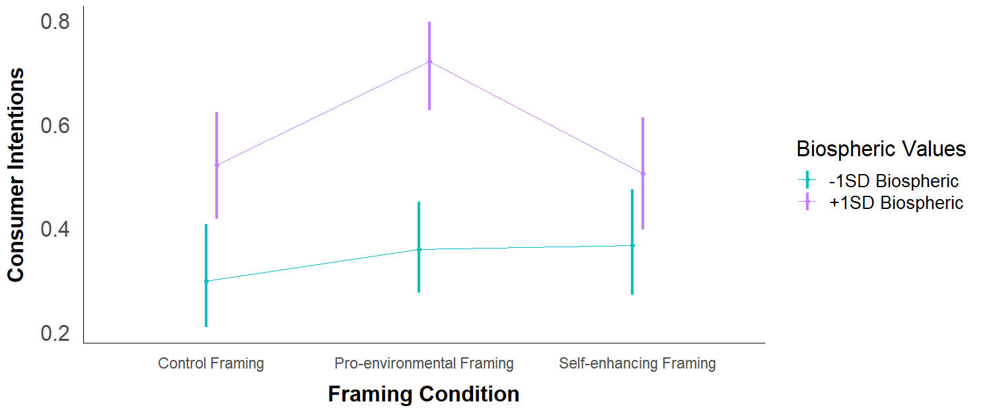

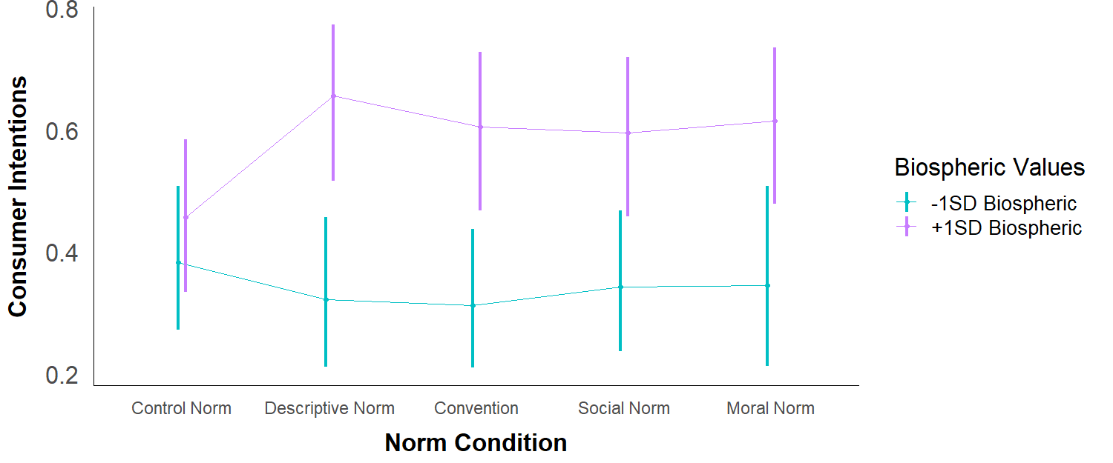

**Consumer intentions:**

**Consumer behaviors:**

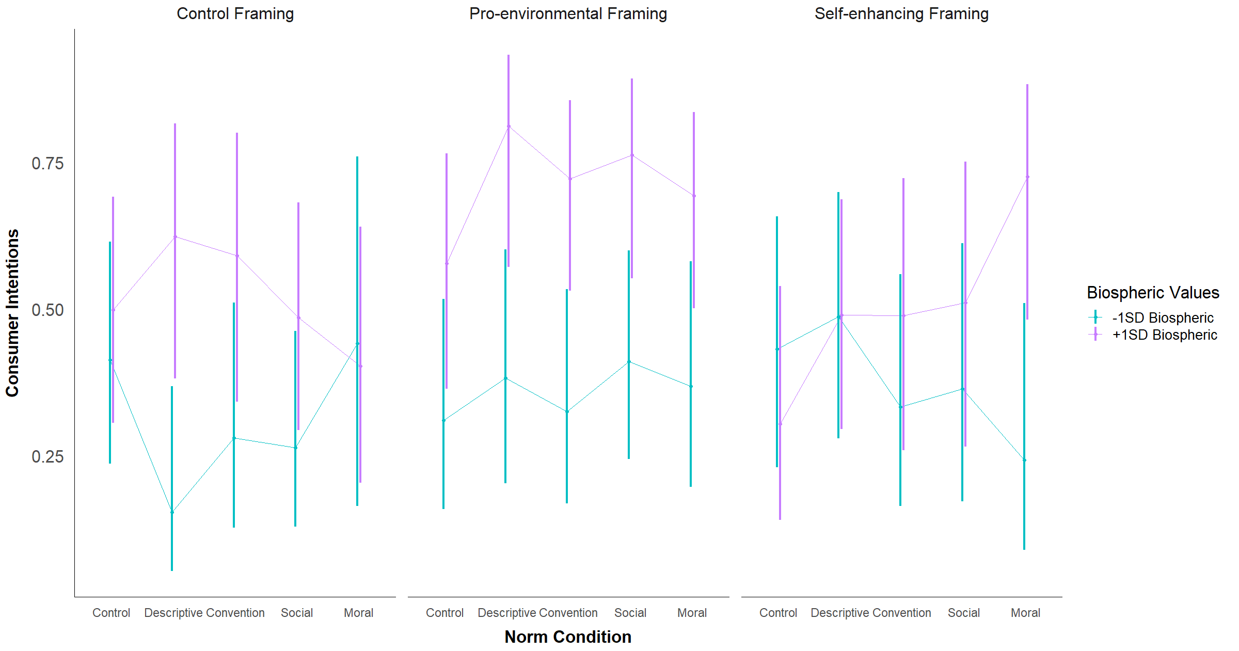

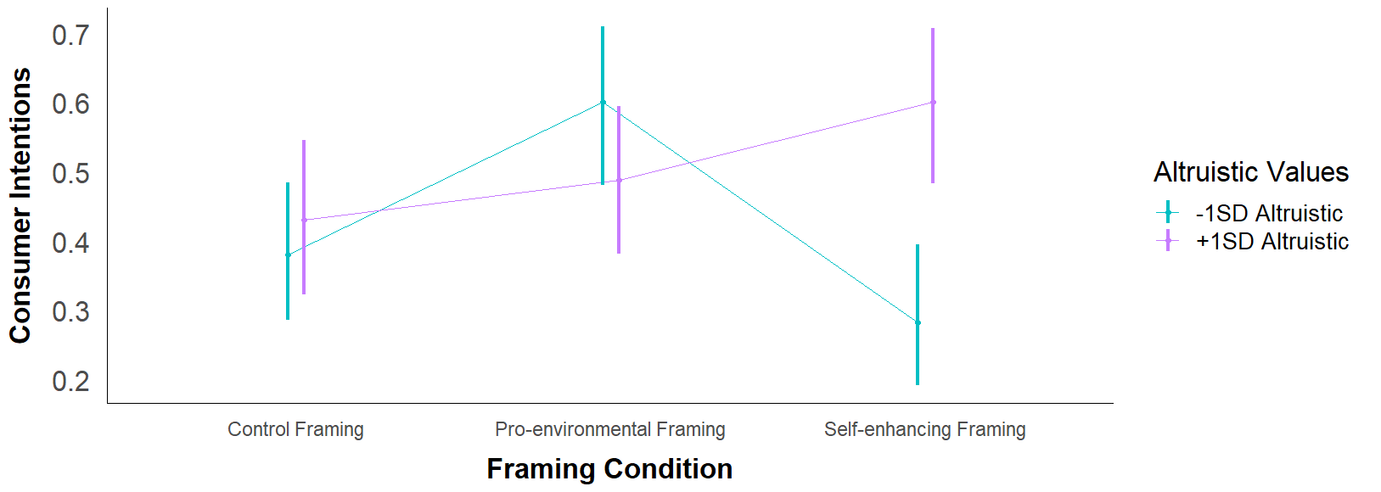

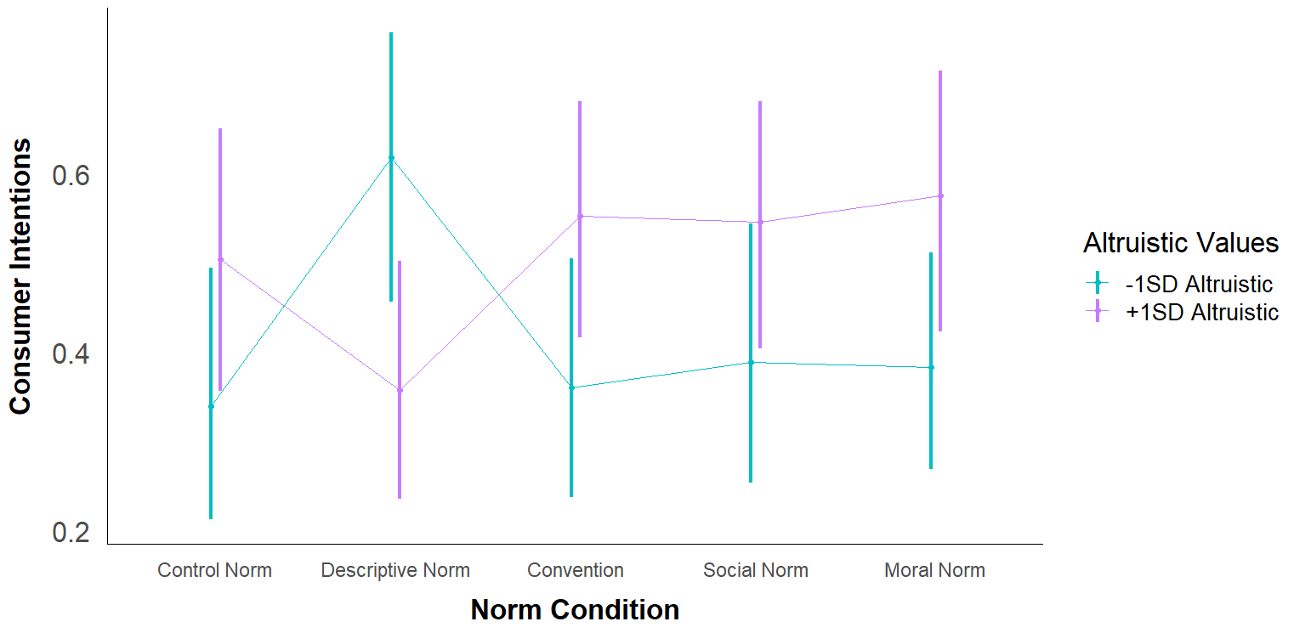

**Consumer intentions:**

**Consumer behaviors:**

